|  |  |  |  |  |
| --- | --- | --- | --- | --- |
|  |  | | | |
|  | |  | | |
| Project: | | MyMav Mobile | | |
| Team: | | Phi | | |
| Class: | | CSE 3310; Spring 2015 | | |
| Module: | | User’s Manual | | |
| Deliverable: | | User’s Manual Document | | |
| Version: | | [1.0] | Date: | [5/5/2015] |

Contributors:

Greg Wilkinson

1000779713

Ph: 740-507-8340

[gregory.wilkinson@mavs.uta.edu](mailto:gregory.wilkinson@mavs.uta.edu)

Kristina Jefferson

1000685986

Ph: 214-717-8758

[Kristina.jefferson@mavs.uta.edu](mailto:Kristina.jefferson@mavs.uta.edu)

Nick Parker

1000732463

Ph: 214-864-7984

[Nick.parker@mavs.uta.edu](mailto:Nick.parker@mavs.uta.edu)

Jose Caballero

1000683861

Ph: 817-948-6585

[Jose.caballero@mavs.uta.edu](mailto:Jose.caballero@mavs.uta.edu)

Revision History

| Version number | Date | Originator | Reason for change | High level description of changes |
| --- | --- | --- | --- | --- |
| 1.0 | 05/05/2015 | Greg Wilkinson | Initial draft | Initial write up of document |
| 1.1 | 05/06/2015 | Greg Wilkinson | Final Revision |  |

TABLE OF CONTENTS

[1. Introduction and Project Overview 4](#_Toc418569565)

[2. Login Screen 5](#_Toc418569566)

[3. Main Menu 6](#_Toc418569567)

[6](#_Toc418569568)

[4. Side Tray 7](#_Toc418569569)

[5. Schedule Management 8](#_Toc418569570)

[5.1 View Schedule 8](#_Toc418569571)

[5.2 Create Schedule 8](#_Toc418569572)

[5.3 Delete Schedule 8](#_Toc418569573)

[5.4 Verify Schedule 8](#_Toc418569574)

[6. Class Management 9](#_Toc418569575)

[6.1 View Class 9](#_Toc418569576)

[6.2 Add Class 9](#_Toc418569577)

[6.3 Drop Class 9](#_Toc418569578)

[7. Search 10](#_Toc418569579)

[8. Set Time Constraint 11](#_Toc418569580)

[9. Profile Settings 12](#_Toc418569581)

# 1. Introduction and Project Overview

MyMav mobile will be an android based application. This application is capable of creating schedules where UT Arlington students can access schedule related items including adding, dropping, and viewing their current/saved schedule(s). Different schedules can be created and saved offline and later verified again that the schedules are still valid.

Students will be greeted with a login screen when the app first opens and can either create a new account in the app or log in to an existing account. Further information about UTA login information is needed to log into UTA's servers to access the up-to-date class schedule information and to re-verify class schedules. Options for adding classes, dropping classes, editing selected schedules, and verifying that seating is available will show up in the main menu when students have logged in.

Proper memory management, battery usage management, and closure of the app is key since the app should be functional and easy to navigate.

# 2. Login Screen

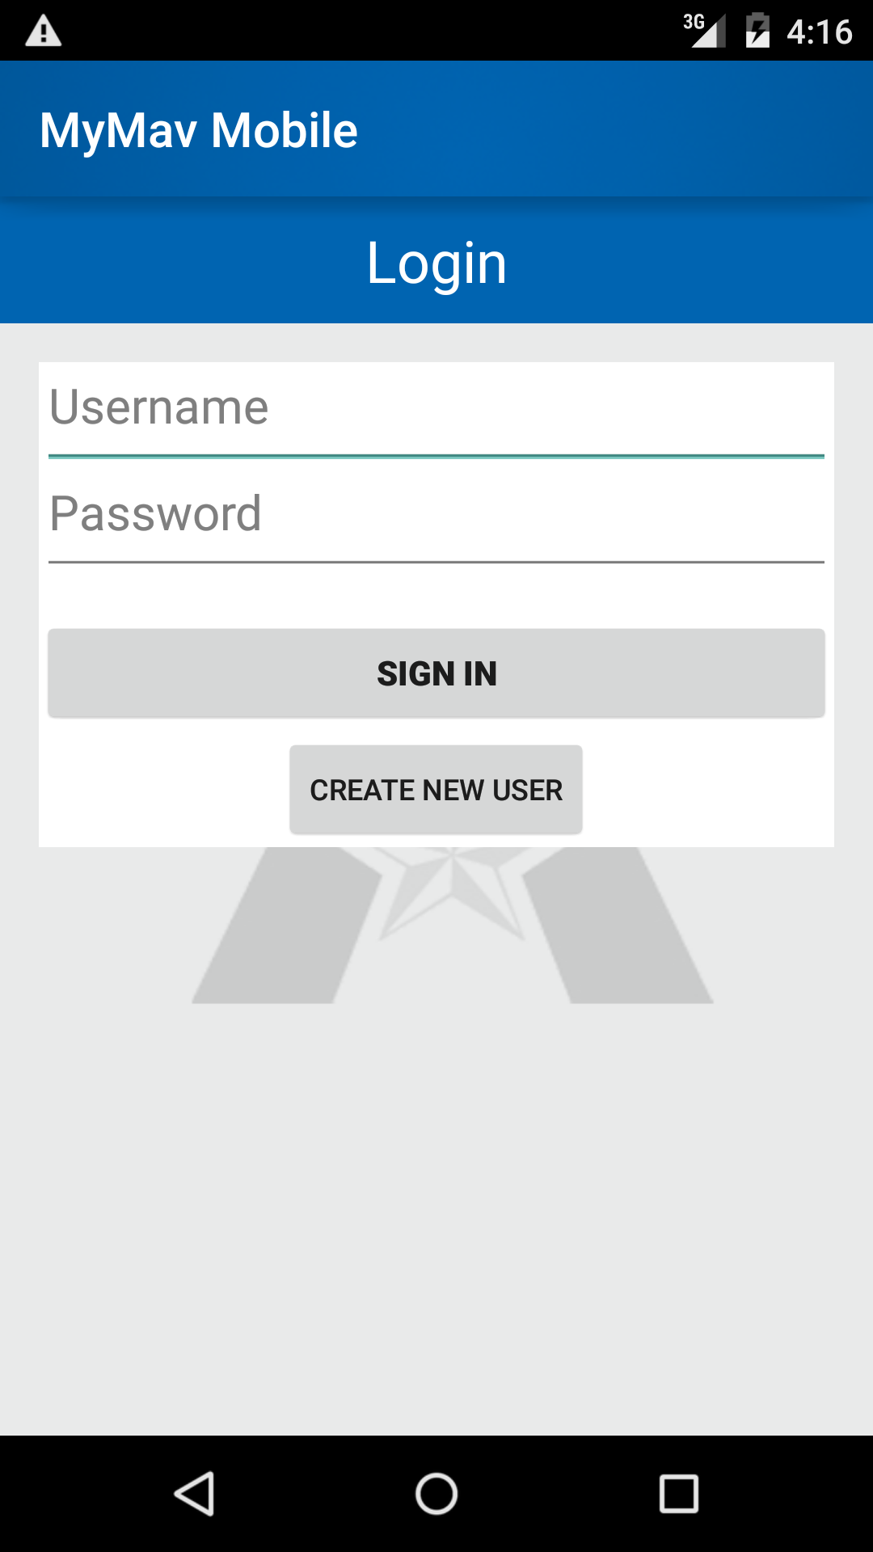

When the application is launched the first screen to display is the login screen. The login screen contains two buttons, one to log the user in once a valid username and password have been created, and the other to move to the create user page.

Username

* Must be a valid University of Texas at Arlington username.
* Password must be the associated password with the MyMav account.
* Requirements for the username is a valid mymav username and password and the @mavs.uta.edu email address related to the account created from the create account page.

# 3. Create User

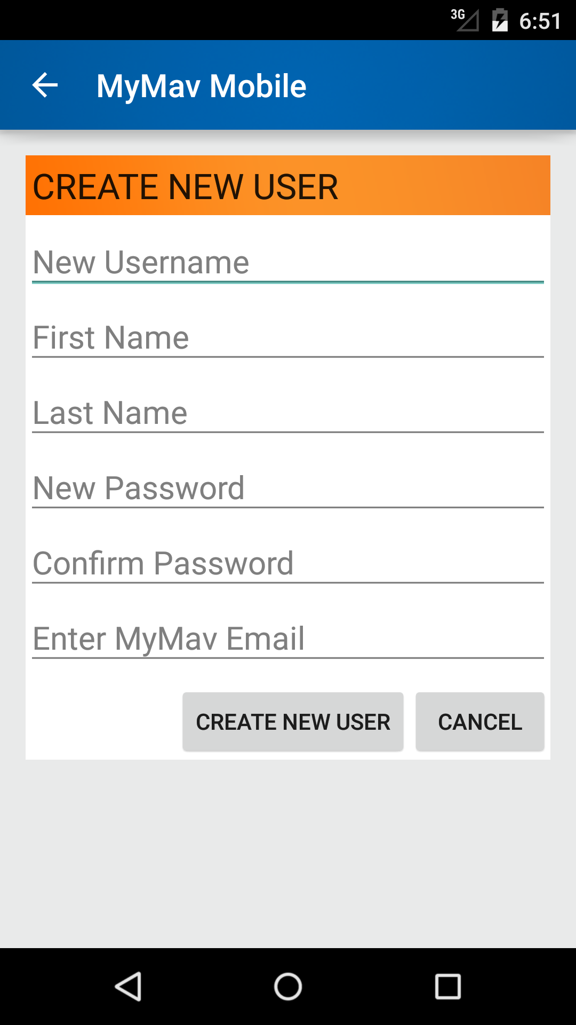

If a user account has not been created then by tapping the create user on the welcome screen will bring up the Create New User page. The username and password will be verified by the MyMav servers to access proper class schedule information.

All fields are required:

* Username must be a valid University of Texas at Arlington username.
* First name and last name of student.
* The password will be the same as the MyMav password.
* The email must be a valid mavs.uta.edu email set up through the school.

# 4. Main Menu

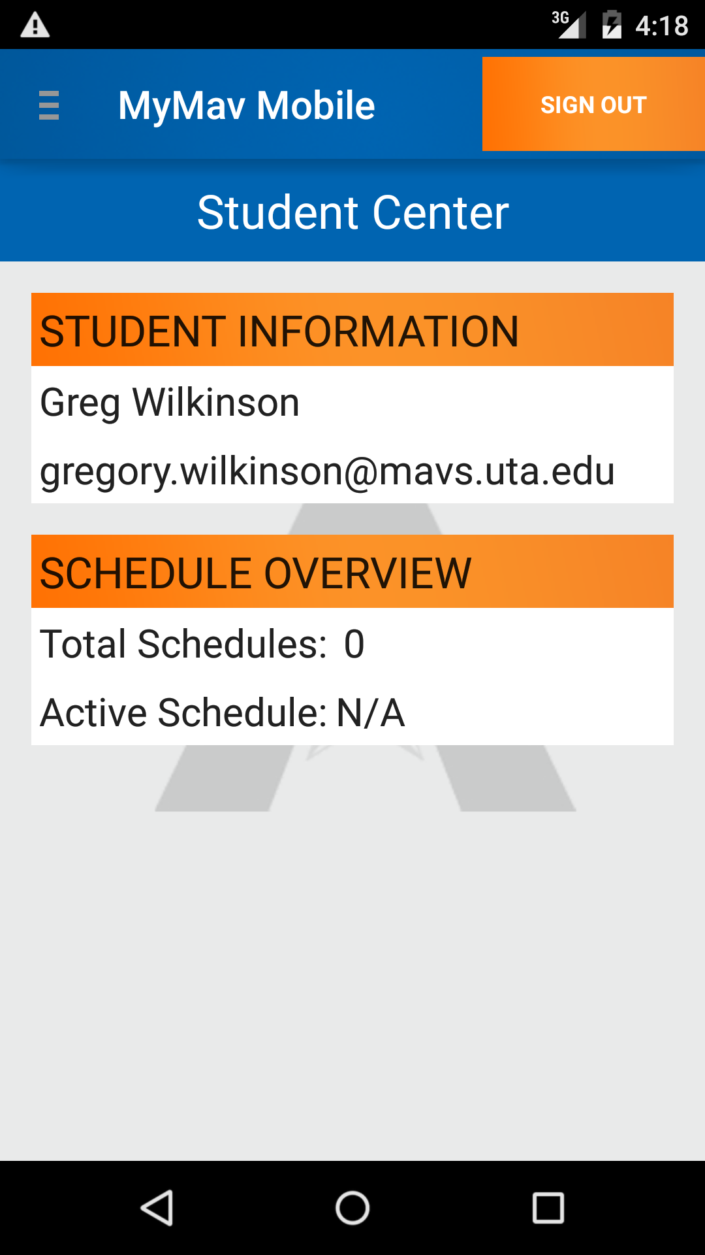Once the student has logged in successfully the main navigation and information page is displayed. In the top left corner is the navigation tray that leads to other functions of the application. In the top right the user can sign out. The Student information displays the user’s name and email saved in the account. Also listed is the number of saved schedules and the active schedule to be edited.

# 4. Side Tray

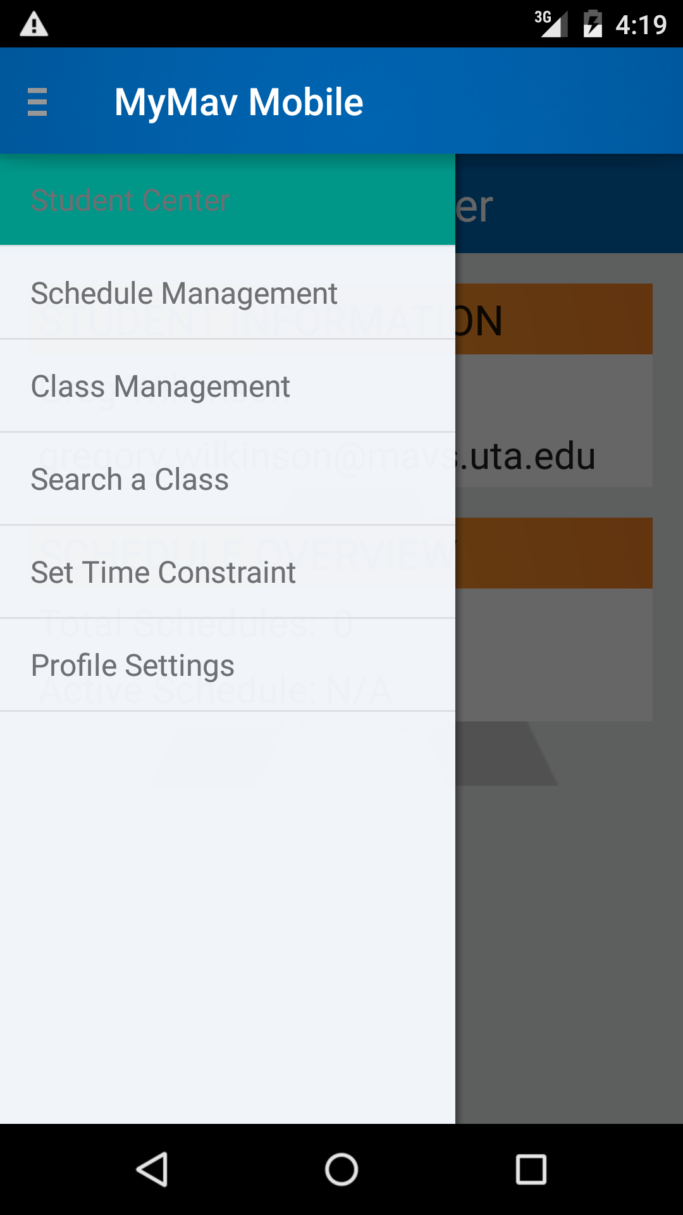When the user taps on the menu tab in the top left of the screen the menu navigation tray is displayed. This is the main navigation to the different functions of the application.

Student Center – Displays current information including the user’s name, email, and number of saved schedules and active schedule to be edited.

Schedule Management – Creation, deletion, and selecting a schedule to be the active schedule to be edited are listed under this selection.

Class Management – Adding, deleting, and verifying classes added to the active schedule are listed under this selection.

Search a class – Sorting through the classes available to be added to schedules is displayed under this selection.

Set Time Constraint – This allows the user to block out time in the schedule where verify schedule will check if a class is scheduled during those times.

Profile Settings – User can edit the stored name and password on the phone.

# 5. Schedule Management

## C:\Users\mynam_000\AppData\Local\Microsoft\Windows\INetCache\Content.Word\view schedules.png5.1 View Schedule

This will display the active schedule which will allow adding and deleting classes from that schedule. Selecting a schedule from the list below will set it to the active schedule. The active schedule will also allow the user to see the classes added to that schedule under the View Scheduled classes tab.

## 5.2 Create Schedule

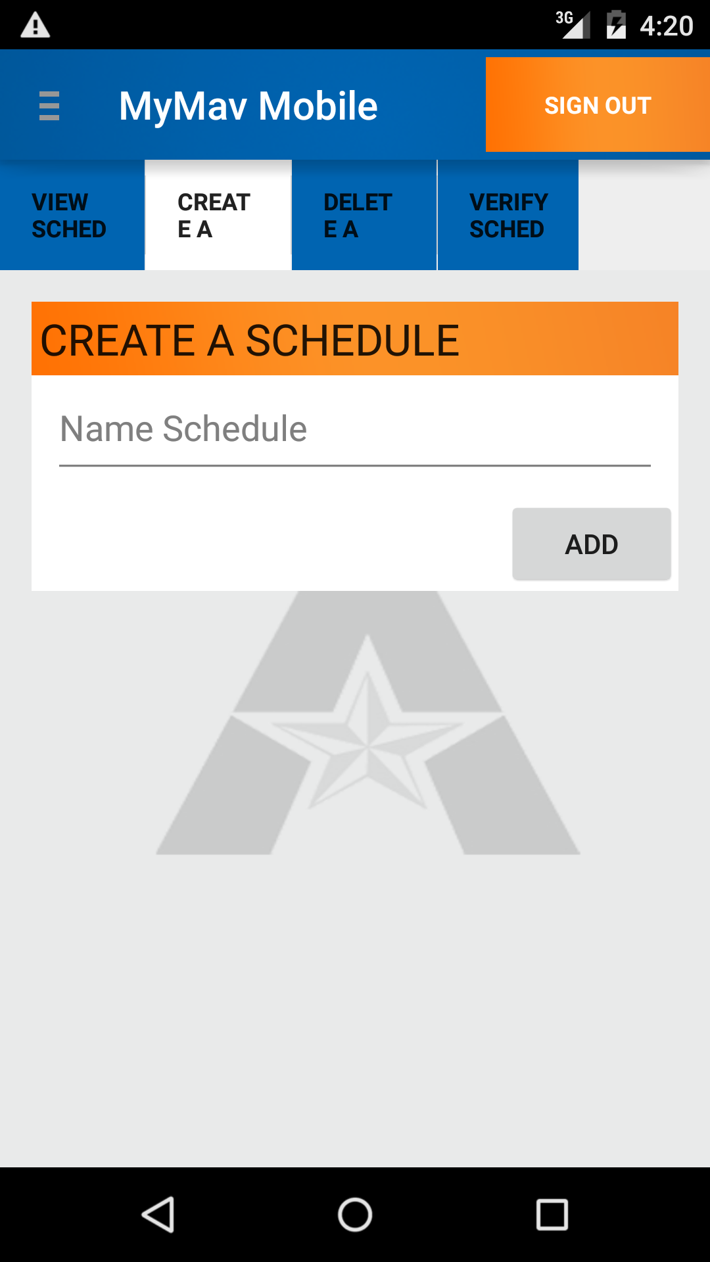Adding a name for the new schedule and then tapping the Add button will create a new schedule and also set it as the active schedule. The active schedule will allow adding/deleting classes from the schedule.

## 5.3 Delete Schedule

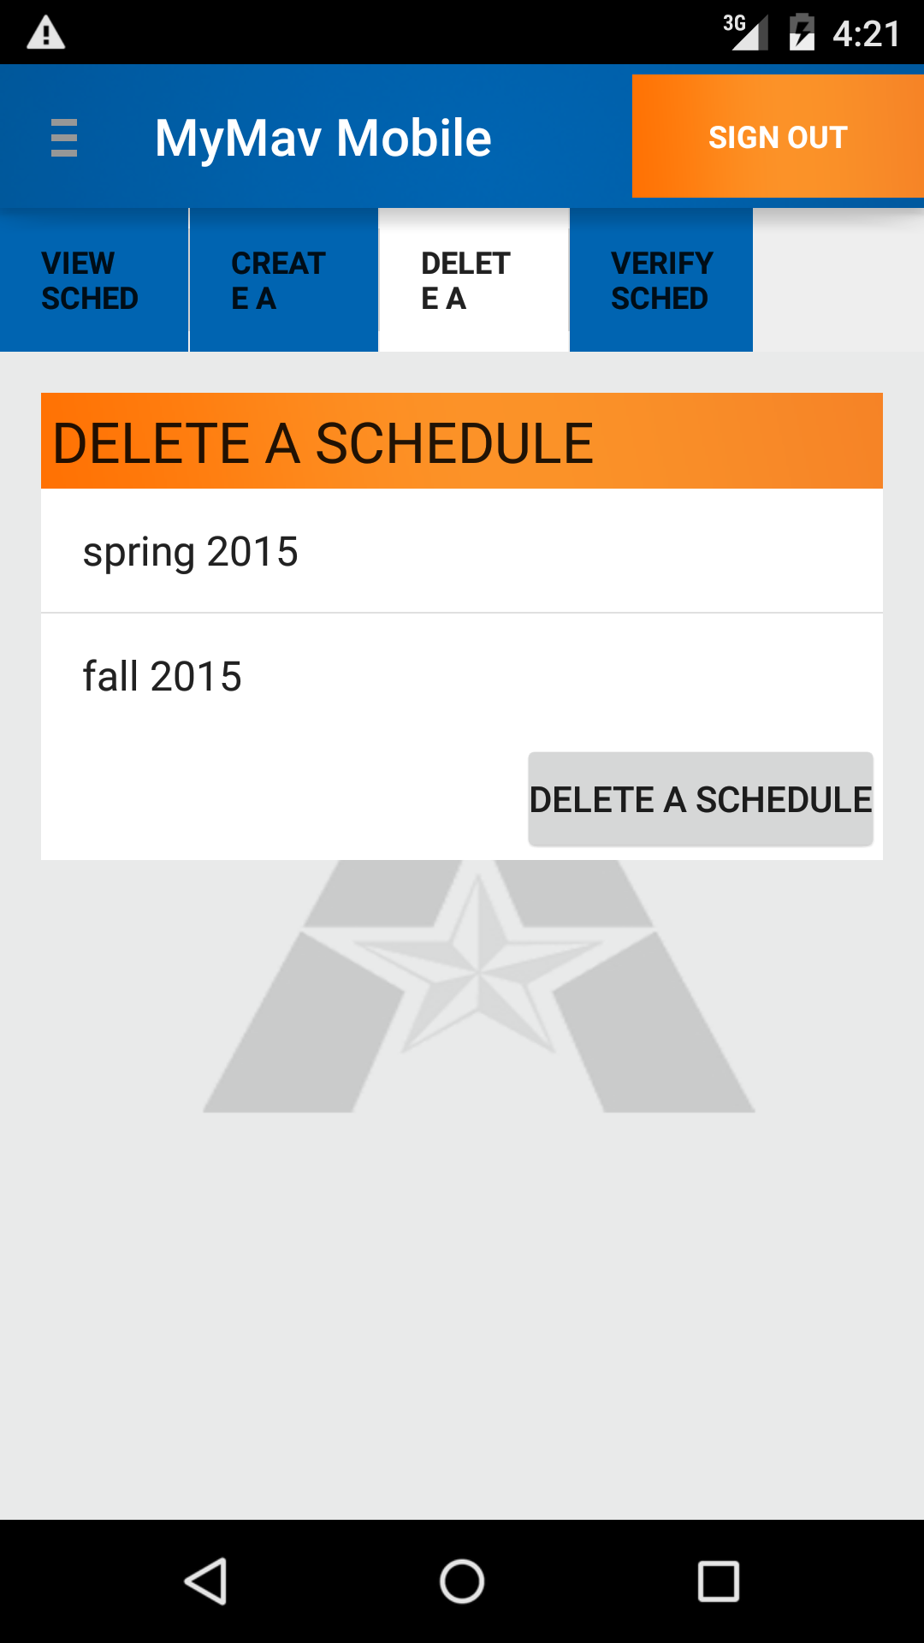From the list of created schedules the user can highlight a schedule and tap the delete button to remove the saved schedule and associated classes from the database.

## C:\Users\mynam_000\AppData\Local\Microsoft\Windows\INetCache\Content.Word\verify schedule.png5.4 Verify Schedule

By selecting a schedule from the list displayed and tapping the verify schedule button the app will check the current enrollment in the class to see whether there are seats available, check to make sure there are no time conflicts with other classes on the schedule, and check the time that the user has blocked out of the schedule and display whether or not the schedule meets those requirements. The application will display how many errors there are with the schedule but will not specify which classes do not meet the requirements.

# 6. Class Management

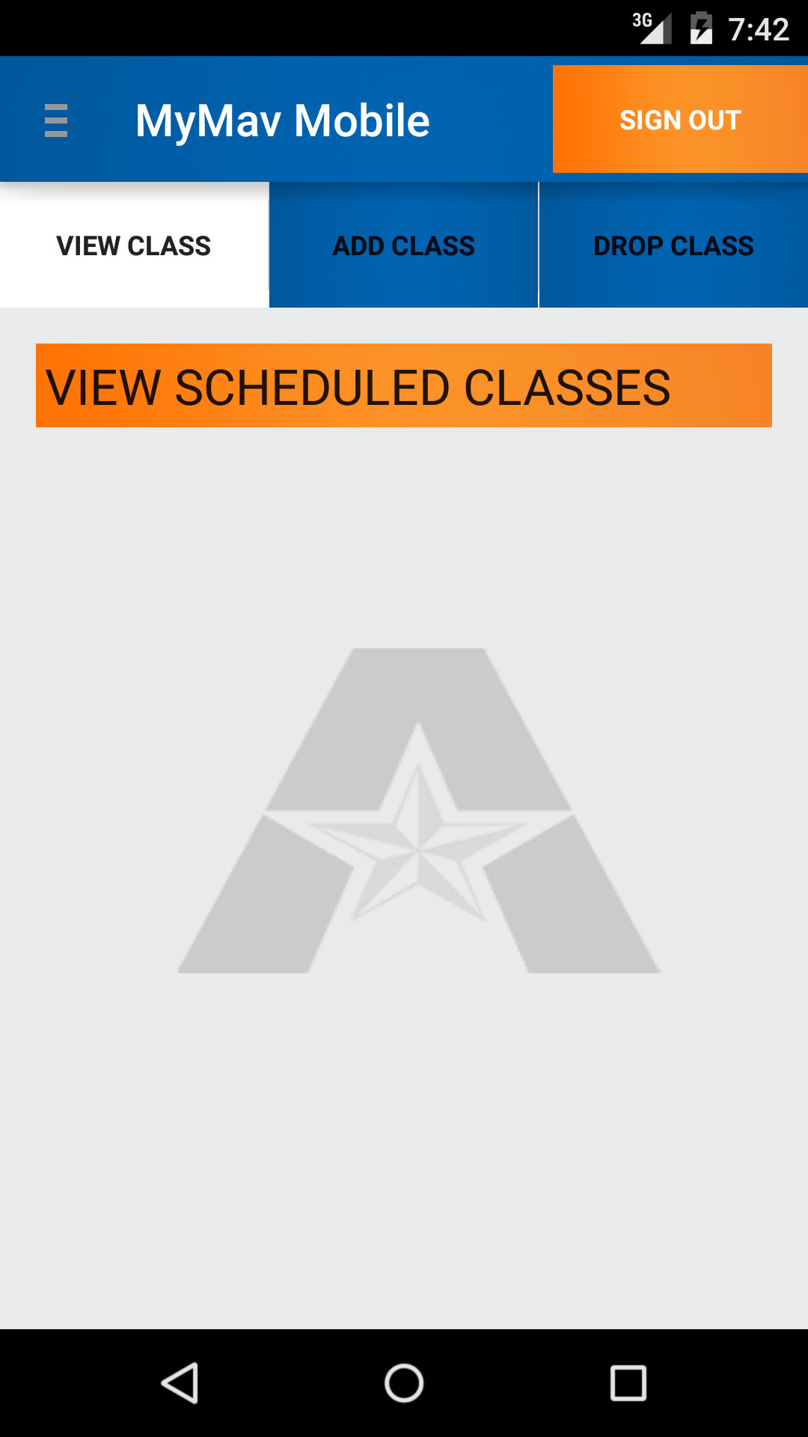

## 6.1 View Class

This will display the active schedules’ classes that have been added. The active schedule name will display N/A if a schedule has not been set as the active class and the page will not display any classes in this case.

## 

## 6.2 Add Class

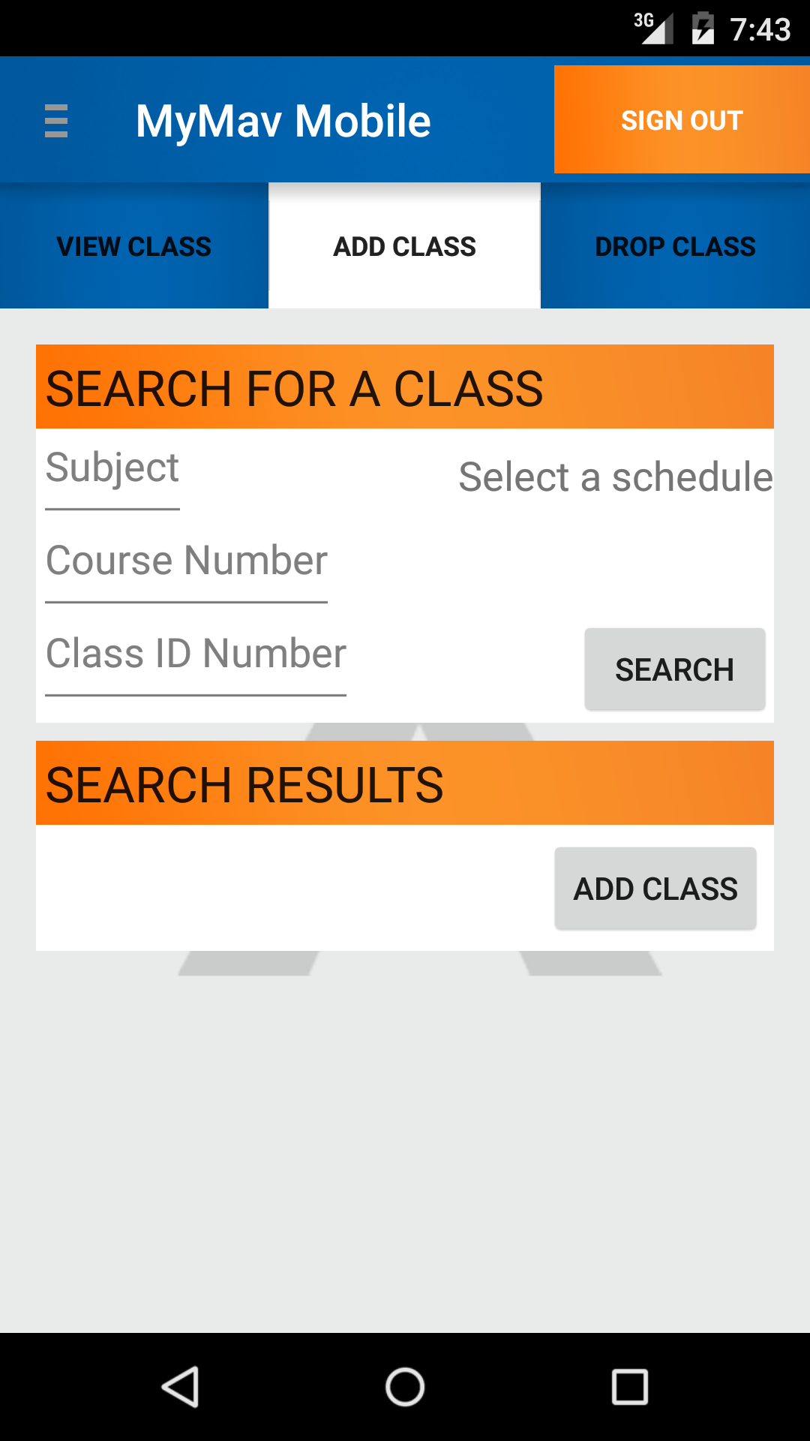

## 6.3 Drop Class

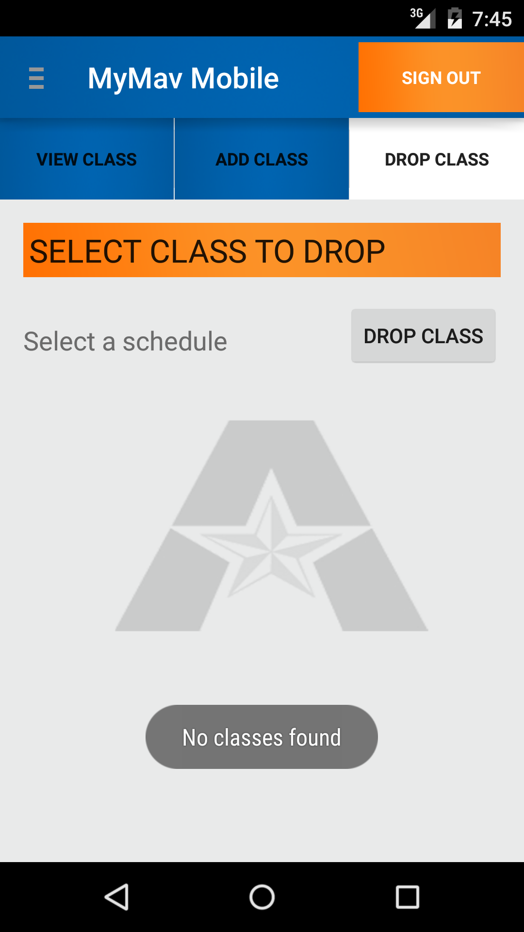

# 7. Search

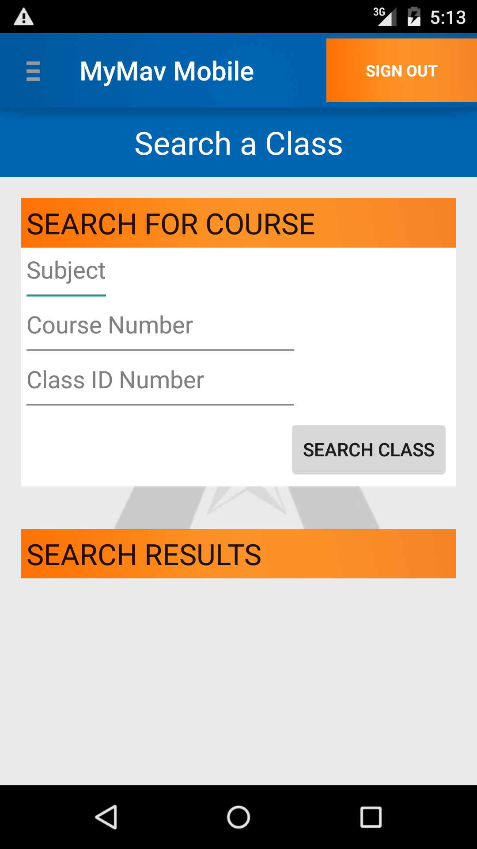

# 8. Set Time Constraint

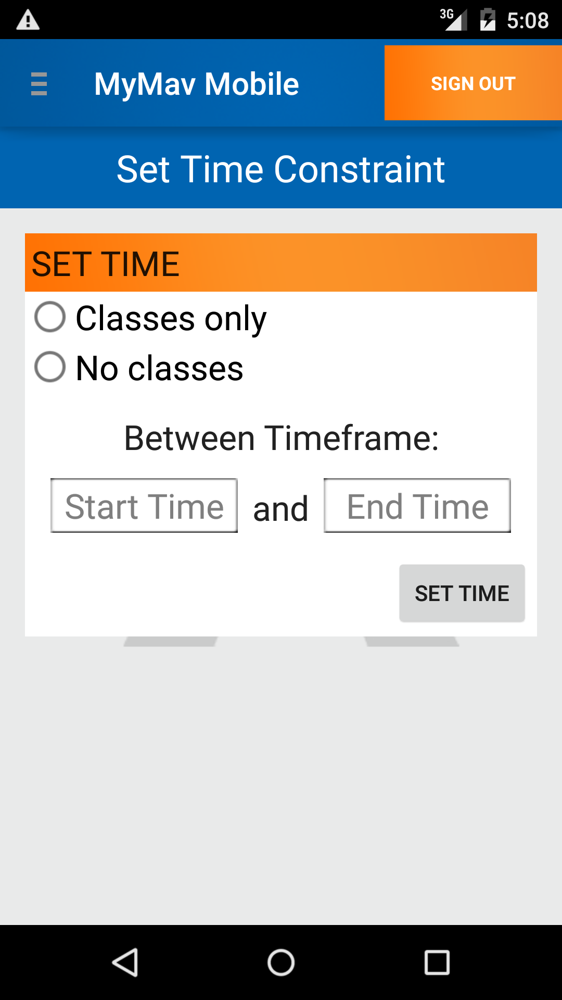

# 9. Profile Settings

